# Weekly Contribution – 28/03/21

**Worked on the UI/UX for the Account, Leaderboard and Saved Trips Pages:**

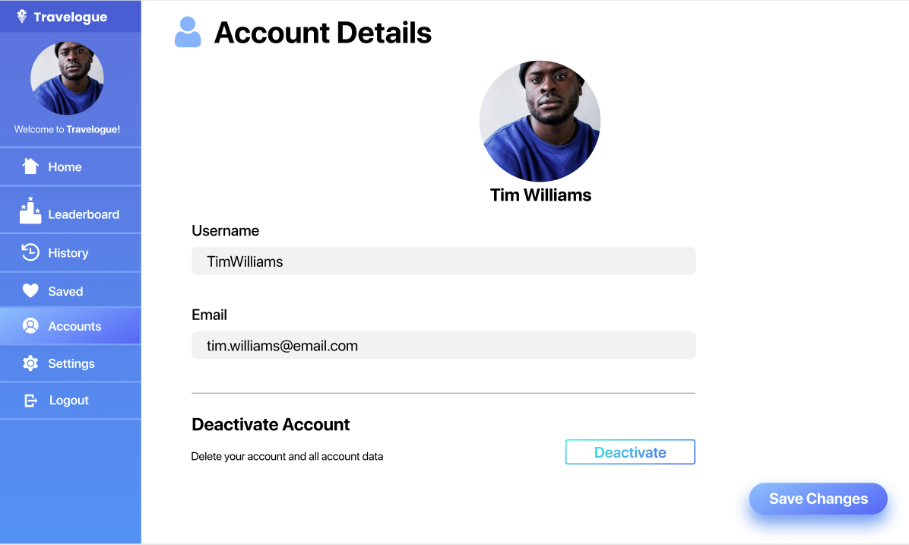





**Completed research on how to utilise Typescript with react**

Using Typescript with react ensure that all props, hooks and components, this helps the application maintain intent when initialising variables and leads to more readable and understandable code in the long run. React x Typescript is a powerful combo as it allows you too:

* Catch problems earlier
* Easily navigate code
* Fast refactoring. ...
* Bug Predictability

Below is a snippit of code which I found interesting when doing my research.

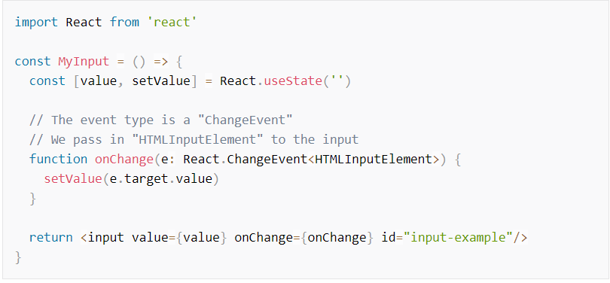

Below you can find the sources of information that my summary paragraph drew from:

<https://youtu.be/Z5iWr6Srsj8>

<https://www.sitepoint.com/react-with-typescript-best-practices/>